1. **Work in groups and summarise the advice in each text in one sentence. Include the sentences in the table below.**

Group A reads texts 1 to 3

Group B reads texts 4 to 6

Group C reads texts 7 to 9

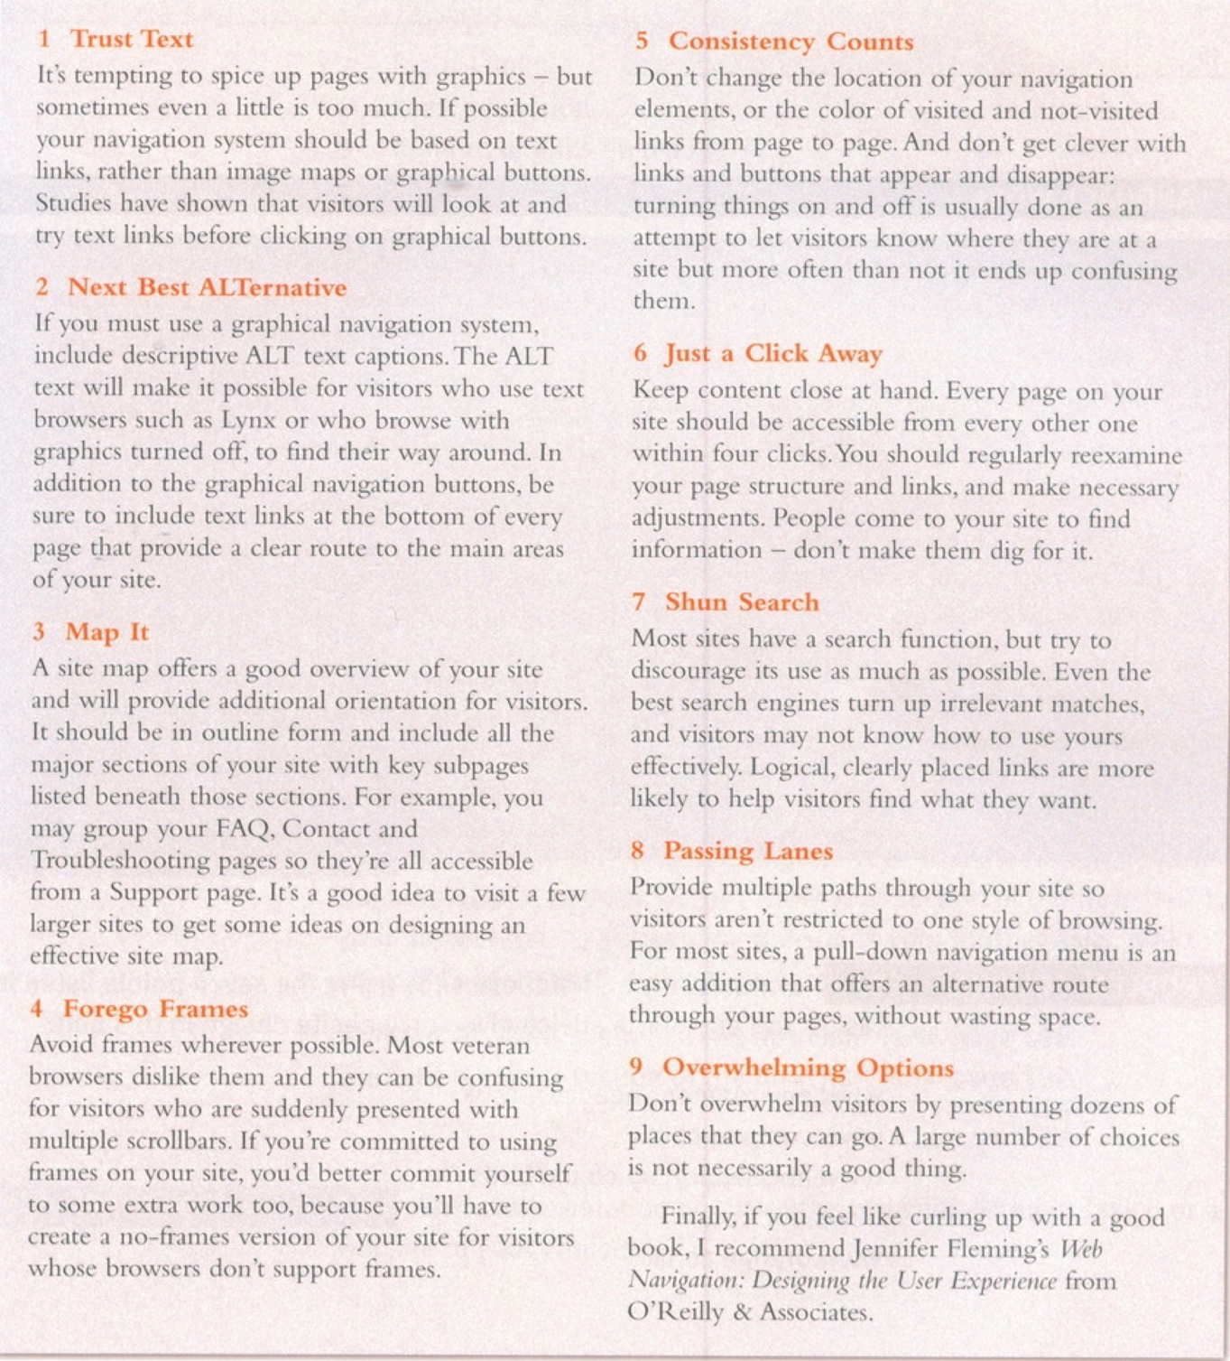

**Complete this table summarising the whole text:**

|  |  |
| --- | --- |
| **Text** | **Advice** |
| 1. |  |
| 2. |  |
| 3. |  |
| 4. |  |
| 5. |  |
| 6. |  |
| 7. |  |
| 8. |  |
| 9. |  |

1. **Summarise the excerpt below on Reverse engineering. Follow the suggested steps in order to provide three different versions of summaries.**

Reverse engineering involves examining carefully the construction or composition of a product, so as to build a copy of it. Initially, it only applied to the reproduction of computer hardware. Now, it also concerns attempts at new representations of existing software systems. Essentially, the whole process aims to extract information related to the design stage, which is the most conceptual part of a system. One frequent use of reverse engineering is for a developer to reuse the code of a current database application. Since database management systems use their own programming languages, the developer is relieved from the burden of rewriting the same applications for another database. Through a code-generating process, organisations greatly reduce the time and cost needed in order to utilize current applications to a new database system. Another use of reverse engineering relates to the production of tools known as compilers. Compilers are translators which convert a source language into machine language that the computer can execute. Reverse engineering compilers read the machine learning language of the software provided by the manufacturer and produce the source code.

A. Use the following table as preparation for your first version of a summary. Combine all your notes into a cohesive paragraph of about 90 words.

|  |  |
| --- | --- |
| *Locate the topic sentence* |  |
| *Paraphrase the topic sentence* |  |
| *Make a list of supporting information, explaining it in your own words.* |  |

B. Remove words that are not essential to meaning and draft a summary of about 60 words.

C. Rephrase and condense further by producing a summary of 30 words in total. Make sure you have not omitted essential information.

Extension activity

1. Writing a program is much like writing a paper. A significant amount of creativity is involved, and many of the same rules apply regarding copyright and intellectual property.

Plan a group discussion in class on the topic of : *Programming and Plagiarism*. Consider the following ideas to start the discussion:

A “Plagiarism is a common problem in programming courses, especially in today’s copy-paste generation.”

B “Reuse is encouraged in Object-Oriented programming, thus obviously elements of reuse are not automatically plagiarism.”

Tips for good contributions in a discussion:

|  |
| --- |
| * Listen carefully * Paraphrase to check for understanding * Explain arguments * Show links to other points * Encourage others to speak * Ask politely for clarifications * Build on points made by others * Be inspiring and creative |

2. Watch the following video material extracted from a webinar on Academic Integrity and Code Plagiarism presented by Turnitin. (For the full version of the video, see: <https://www.facebook.com/watch/?v=1720483645009035>).

Discuss the following ideas:

1. What is Turnitin and what is the Turnitin mission?
2. What does the Evolution of Plagiarism refer to?
3. What is Programming Plagiarism and why isn’t it a new trend?
4. How can plagiarism be avoided?

**Language focus**

Identifying the source

Most **summaries** will have a sentence near the beginning that contains two elements: **the source and the main idea**. Notice the use of the **present tense** in many of the examples:

* According to Fairchild (2021), ___________(the main idea)
* Ydev, Kamara and Gupta’s 2021 paper on federated machine learning discusses ______(main idea)
* Bernstein (2021) states/claims/argues/maintains that ______
* Barinaga (2019) suggests/asserts/hypothesizes/states/concludes that _______
* Lamport [1] proposed/demonstrated/found/identified ______
* ____________was first reported/given/identified in [1].

You may cite your source material following [APA](https://apastyle.apa.org/) (American Psychological Association), MLA (Modern Language Association), IEEE (Institute of Electrical and Electronics Engineers). The APA and MLA refer to sources similarly (by author and date).

**Note** : Always check the style guidelines for your discipline to learn about submission instructions for Authors.

The following citations style should be used for the Bachelor Dissertation Thesis

For more info, see <https://www.cs.ubbcluj.ro/licenta-disertatie-2021/>;

For the style guide, see: <https://www.cs.ubbcluj.ro/wp-content/uploads/ghid-finalizare-2021.docx>;

**Books**

Author, title of the paper, Publisher, Place, Year

|  |  |
| --- | --- |
| In Text – Parenthetical citation | Reference list – Bibliography (usually alphabetical) |
| [1] | DeVore, R.A., Lorentz, G.G.: Constructive Approximation, Springer, Berlin, 1993. |

**Articles**

Author, Title of the article, Journal name, Issue/Number, Year, Page number):

|  |  |
| --- | --- |
| In Text – Parenthetical citation | Reference list - Bibliography |
| [Berens1972] | Berens, H., Lorentz, G.G.: Inverse theorems for Bernstein polynomials, Indiana Univ. Math. J., 21 (1972), 693-708. |

**Online resources**

Author Name and Surname, Lecture Title/Course Pack Title, DOI :

|  |  |
| --- | --- |
| In Text – Parenthetical citation | Reference list - Bibliography |
| [Wong] | Wong P: Fixed Point Theory and Applications, http://abacus.bates.edu/ pwong/research/mini-course.pdf |

**Electronic documents: datasets, databases**

Title of data set (Version number) [Description of form], Author/Rightsholder, Place, Year

|  |  |
| --- | --- |
| In Text – Parenthetical citation | Reference list - Bibliography |
| [2] *** | Floating point controller board DS1102 documentation, dSPACE Company, Paderborn, Germany, 2006 |

**Useful language : Reporting verbs**

There is a wide range of **reporting verbs** that you may use when referring to your source material.

There are **three ways to refer to source material**:

**Affirmation** - writers typically express their **total agreement to what they have reported**. The writers believe in the proposition or informational content cited in their work. Some of the reporting verbs are: *indicate*, *show*, *discover*, *find* etc.

**Hedging** - Refers to expressing **partial commitment** to the cited proposition or informational. Writers are very cautious about the claim of the proposition or informational content. They typically use reporting verbs such as *suggest*, *recommend*, and *propose*, etc.

**Neutrality** - Refers to taking up an **objective stance** or using ‘unevaluated’ reporting verbs towards proposition or informational content cited in your work. Writers typically report what the author says without using evaluative reporting verbs; such reporting verbs are: *compare*, *report*, *state*, and *see* etc.

1. Consider the following tables (2,3,4) sumarising the use of reporting verbs across four disciplines: Applied Linguistics, Accounting, Engineering and Medicine (for the full reference, see: <https://files.eric.ed.gov/fulltext/EJ1239147.pdf>). Review the verbs associated with the field of Engineering and formulate a conclusion/interpretation regarding the findings of the study.

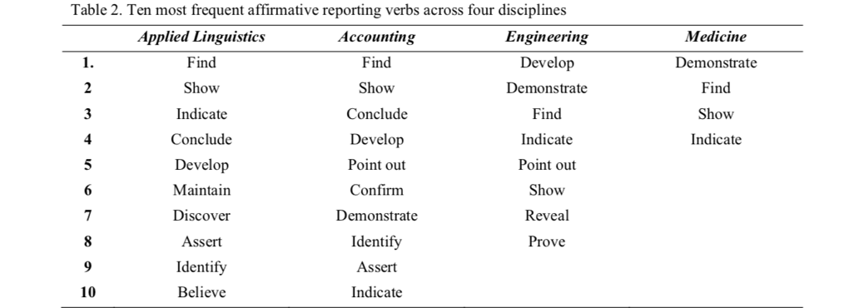

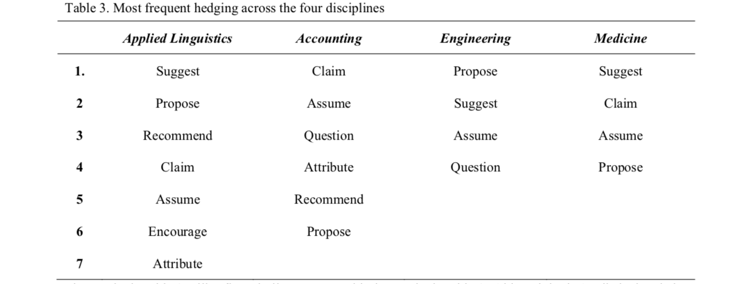

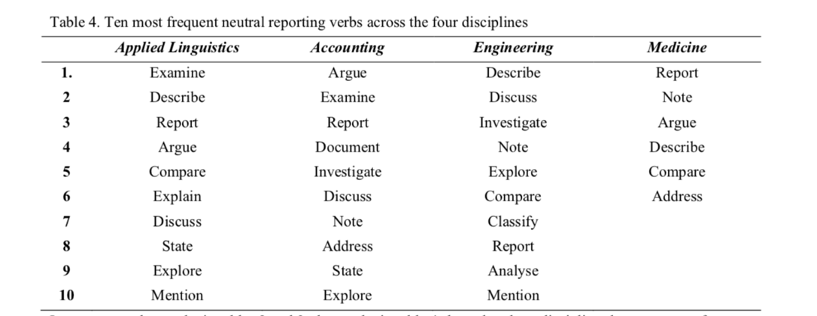

2. Focus on the following examples of scientific articles in the field of CS and select the reporting verbs (a), create a small data set (a corpus) that you can analyse to gain some insights into the use of reporting verbs in your discipline (b) and identify the tense(s) of the reporting verbs (b). Do your results match with those in the table?

1. <https://www.sciencedirect.com/science/article/pii/S1319157819301533> ( see *Related work* section)
2. <https://www.sciencedirect.com/science/article/pii/S157401372100040X> ( see *Introduction*: from “Although there are other reviews in the field […]2D reconstruction methods”
3. <https://www.sciencedirect.com/science/article/pii/S1319157821002238> (see *Introduction*: from “ Recently, several studies […] 15dB.”
4. <https://www.sciencedirect.com/science/article/pii/S1319157821002664> (see *Previous reviews*: from “In the following paragraphs, we will draw a panoramic summary [...] Smart Farming”

3. Some reporting verbs are less objective than others. Can you identify which verbs in the tables shown above seem objective and which have the potential to be evaluative?

|  |  |  |
| --- | --- | --- |
|  | Objective verb | Evaluative verb |
| Describe  Recommend  Claim  Assume  Contend  Propose  Theorize  Examine  Support |  |  |